

**ONLINE BOOKING SALON AND SPA**

**PURE AND APPLIED SCIENCES**

**COMPUTER SCIENCE**

RESEARCH SUBMITTED IN ARTICLE FULFILLMENT FOR THE DEGREE OF COMPUTER SCIENCE OF KIRINYAGA UNIVERSITY

**JAMES MBURU WANJIRU**

**CT101/G/6265/19**

**SUPERVISOR: Dr KARANI**

**April 2024**

**DECLARATION**

This proposal is my original work and has not been presented in any other university or from any online source for the award of any degree.

Name: James Mburu Wanjiru

Signature: __________________Date: ______________________.

This research project has been submitted for examinations with the approval of the university supervisor

Supervisor:

Name: __________________________________________

Signature _________________ Date: _______________

**DEDICATION**

I dedicate this project to my family for their great support even when things were so tough for me, they constantly kept on encouraging me to work extra hard, my friends for moral support and encouragement throughout my studies and lastly my colleagues and my manager for creating an enabling environment to carry out this project.

**AKNOWLEDGEMENT**

I wish to register my profound gratitude to Almighty God for the guidance and grace throughout my life. I’m also grateful to the entire staff of the KyU institution that my studies educative and worthwhile.

# **ABSTRACT**

Various studies carried out in Kenya show that hair salon and spa do not show the expected upward growth despite their numbers soaring up. Their economic contributions are minimal. The general objective of the study was to establish the influence of entrepreneur’s characteristics on the growth of hair salon and spa enterprises in Kenya. Specific objectives of the study were: to establish the influence of the entrepreneur’s experience on the growth of hair salon and spa enterprises; to establish the influence of the entrepreneur’s training on the growth of hair salon enterprises; to establish the influence of the entrepreneur’s level of education on the growth of hair salon and spa enterprises. Self-administered questionnaires and interview schedules were used for data collection. The sample size for the study comprised 92 owner-managers, one county trade officer, and one MSEDO totaling 94 respondents. Data were processed and analyzed using the statistical package for social scientists (SPSS) version 19 and Microsoft Office Excel 2013. Data were analyzed using descriptive statistics (mean, mode, median, and standard deviation), inferential statistics (correlation analysis and simple linear regression) and ANOVA. It emerged that entrepreneur’s experience, level of education and training influence growth. The study recommended that the government provides intensive training and other support services for the small enterprises to grow, offer an enabling environment to support the small enterprises. Further, there should be information centers in every county and sub-county where MSEs obtain support. Key words: Entrepreneurship, Growth, MSEs, Business Experience, Training, Education Level, Medium enterprises, small enterprises.

ABSTRACT 4

LIST OF FIGURES 6

LIST OF TABLESs 7

LIST OF ABBREVIATIONS 7

CHAPTER ONE 9

INTRODUCTION 9

1.1: Background of the Study 9

1.2: Statement of the Problem 9

1.3: Objectives of the Study 9

1.3.1: General Objectives/ Broad Objective 10

1.3.2: Specific Objectives 11

1.4: Research Questions 11

1.5: Justification of the Study 11

1.6: Scope of the Study 11

CHAPTER TWO 12

LITERATURE REVIEW 12

2.0: Introduction 12

2.1: Theories of growth of MSEs. 12

2.2: Lifecycle Models 13

2.3: Growth Antecedents and Determinants Models. 13

2.5: Conceptual Framework 14

2.6: Related Work 14

2.6.1: Sanitation 14

2.6.2: Client Consultation 14

2.6.3: Hair styling services 14

2.8: Approach 15

CHAPTER THREE 16

RESEARCH DESIGN AND METHODOLOGY 16

3.1: Introduction 16

3.2: Research Design 16

3.3: Target Population 16

3.4: Sampling Design 16

3.4.1: Sample Size Determination 16

3.5: Data collection Techniques 17

3.6: Data analysis methods and procedures 17

3.6.1: Questionnaires 17

3.6.2: Interview Schedule 17

3.7: Development Methodology 17

3.8 Technology for Development 18

CHAPTER 4: DATA ANALYSIS, INTERPRETATION OF FINDINGS AND SYSTEMS DESIGN 18

DATA ANALYSIS, INTERPRETATION OF FINDINGS AND SYSTEMS DESIGN 19

4.0: Introduction 19

4.1: Presentation of Findings 19

4.1.1: Questionnaire Return Rate 19

4.1.2: Category of Respondents 19

4.1.3: Computer usage skills 20

4.3: System Aanalysis 23

4.3.1: Description of the existing system 23

4.3.2: Description of the proposed System 23

4.3.3: Requirements Specifications 23

4.3.3.1: Functional and Non-Functional Requirements 23

4.4: System Design 24

4.4.1: Context Diagram 25

4.4.2: Use Case Model 25

4.4.3: Sequence Diagrams 26

4.4.4 Activity Diagram 27

4.5: Interface Designs 28

4.5.1: Login page for admin 28

4.6: Database Design 30

4.6.1: Customer Table 31

4.7: System Implementation and Testing 31

4.7.1: System testing 32

4.7.2: System Output – Reports 32

4.7.2.1: Add/manage services 32

4.7.2.2: View appointments 32

4.7.2.3: Accept/reject appointment 32

CHAPTER 5: SUMMARY OF FINDINGS, CONCLUSIONS AND RECOMMENDATIONS 32

5.1: Introduction 33

5.2: Summary of findings 33

5.3: Conclusions 33

5.4: Recommendations 33

5.5: Suggestion for further study. 34

References 34

APPENDICES 34

APPENDIX A: PROJECT BUDGET 35

APPENDIX B: IMPLEMENTATION SCHEDULE 35

APPENDIX C: HARDWARE REQUIREMENT 36

APPENDIX D: SOFTWARE REQUIREMENT 37

APPENDIX E: SAMPLE CODE 39

ABSTRACT 4

LIST OF FIGURES 6

LIST OF TABLESs 7

LIST OF ABBREVIATIONS 7

CHAPTER ONE 9

INTRODUCTION 9

1.1: Background of the Study 9

1.2: Statement of the Problem 9

1.3: Objectives of the Study 9

1.3.1: General Objectives/ Broad Objective 10

1.3.2: Specific Objectives 11

1.4: Research Questions 11

1.5: Justification of the Study 11

1.6: Scope of the Study 11

CHAPTER TWO 12

LITERATURE REVIEW 12

2.0: Introduction 12

2.1: Theories of growth of MSEs. 12

2.2: Lifecycle Models 13

2.3: Growth Antecedents and Determinants Models. 13

2.5: Conceptual Framework 14

2.6: Related Work 14

2.6.1: Sanitation 14

2.6.2: Client Consultation 14

2.6.3: Hair styling services 14

2.8: Approach 15

CHAPTER THREE 15

RESEARCH DESIGN AND METHODOLOGY 16

3.1: Introduction 16

3.2: Research Design 16

3.3: Target Population 16

3.4: Sampling Design 16

3.4.1: Sample Size Determination 16

3.5: Data collection Techniques 17

3.6: Data analysis methods and procedures 17

3.6.1: Questionnaires 17

3.6.2: Interview Schedule 17

3.7: Development Methodology 17

3.8 Technology for Development 18

CHAPTER 4: DATA ANALYSIS, INTERPRETATION OF FINDINGS AND SYSTEMS DESIGN 18

DATA ANALYSIS, INTERPRETATION OF FINDINGS AND SYSTEMS DESIGN 19

4.0: Introduction 19

4.1: Presentation of Findings 19

4.1.1: Questionnaire Return Rate 19

4.1.2: Category of Respondents 19

4.1.3: Computer usage skills 20

4.3: System Aanalysis 23

4.3.1: Description of the existing system 23

4.3.2: Description of the proposed System 23

4.3.3: Requirements Specifications 23

4.3.3.1: Functional and Non-Functional Requirements 23

4.4: System Design 24

4.4.1: Context Diagram 25

4.4.2: Use Case Model 25

4.4.3: Sequence Diagrams 26

4.4.4 Activity Diagram 27

4.5: Interface Designs 27

4.5.1: Login page for admin 28

4.6: Database Design 30

4.6.1: Customer Table 31

4.7: System Implementation and Testing 31

4.7.1: System testing 32

4.7.2: System Output – Reports 32

4.7.2.1: Add/manage services 32

4.7.2.2: View appointments 32

4.7.2.3: Accept/reject appointment 32

CHAPTER 5: SUMMARY OF FINDINGS, CONCLUSIONS AND RECOMMENDATIONS 32

5.1: Introduction 33

5.2: Summary of findings 33

5.3: Conclusions 33

5.4: Recommendations 33

5.5: Suggestion for further study. 34

References 34

APPENDICES 34

APPENDIX A: PROJECT BUDGET 34

APPENDIX B: IMPLEMENTATION SCHEDULE 35

APPENDIX C: HARDWARE REQUIREMENT 36

APPENDIX D: SOFTWARE REQUIREMENT 37

APPENDIX E: SAMPLE CODE 39

ABSTRACT 4

LIST OF FIGURES 6

LIST OF TABLESs 7

LIST OF ABBREVIATIONS 7

CHAPTER ONE 9

INTRODUCTION 9

1.1: Background of the Study 9

1.2: Statement of the Problem 9

1.3: Objectives of the Study 9

1.3.1: General Objectives/ Broad Objective 10

1.3.2: Specific Objectives 11

1.4: Research Questions 11

1.5: Justification of the Study 11

1.6: Scope of the Study 11

CHAPTER TWO 12

LITERATURE REVIEW 12

2.0: Introduction 12

2.1: Theories of growth of MSEs. 12

2.2: Lifecycle Models 13

2.3: Growth Antecedents and Determinants Models. 13

2.5: Conceptual Framework 14

2.6: Related Work 14

2.6.1: Sanitation 14

2.6.2: Client Consultation 14

2.6.3: Hair styling services 14

2.8: Approach 15

CHAPTER THREE 15

RESEARCH DESIGN AND METHODOLOGY 16

3.1: Introduction 16

3.2: Research Design 16

3.3: Target Population 16

3.4: Sampling Design 16

3.4.1: Sample Size Determination 16

3.5: Data collection Techniques 17

3.6: Data analysis methods and procedures 17

3.6.1: Questionnaires 17

3.6.2: Interview Schedule 17

3.7: Development Methodology 17

3.8 Technology for Development 18

CHAPTER 4: DATA ANALYSIS, INTERPRETATION OF FINDINGS AND SYSTEMS DESIGN 18

DATA ANALYSIS, INTERPRETATION OF FINDINGS AND SYSTEMS DESIGN 19

4.0: Introduction 19

4.1: Presentation of Findings 19

4.1.1: Questionnaire Return Rate 19

4.1.2: Category of Respondents 19

4.1.3: Computer usage skills 20

4.3: System Aanalysis 23

4.3.1: Description of the existing system 23

4.3.2: Description of the proposed System 23

4.3.3: Requirements Specifications 23

4.3.3.1: Functional and Non-Functional Requirements 23

4.4: System Design 24

4.4.1: Context Diagram 25

4.4.2: Use Case Model 25

4.4.3: Sequence Diagrams 26

4.4.4 Activity Diagram 27

4.5: Interface Designs 27

4.5.1: Login page for admin 28

4.6: Database Design 30

4.6.1: Customer Table 31

4.7: System Implementation and Testing 31

4.7.1: System testing 32

4.7.2: System Output – Reports 32

4.7.2.1: Add/manage services 32

4.7.2.2: View appointments 32

4.7.2.3: Accept/reject appointment 32

CHAPTER 5: SUMMARY OF FINDINGS, CONCLUSIONS AND RECOMMENDATIONS 32

5.1: Introduction 33

5.2: Summary of findings 33

5.3: Conclusions 33

5.4: Recommendations 33

5.5: Suggestion for further study. 34

References 34

APPENDICES 34

APPENDIX A: PROJECT BUDGET 34

APPENDIX B: IMPLEMENTATION SCHEDULE 35

APPENDIX C: HARDWARE REQUIREMENT 36

APPENDIX D: SOFTWARE REQUIREMENT 37

APPENDIX E: SAMPLE CODE 39

# 

# LIST OF FIGURES

Figure 1: Flow diagram

Figure 2: data flow diagram

Figure 3: Flow diagram

Figure 4: system development life cycle

# 

# LIST OF TABLESs

Table 1: Questionnaire Return Rate 18

Table 2: Project Budget………………………………………………………………………………………………………………………….31

Table 3:Hardware requrements…………………………………………………………………..33

Table 4:Software requrements 34

# LIST OF ABBREVIATIONS

|  |  |  |
| --- | --- | --- |
| **S. No.** | **Acronym** | **Full Form** |
| 1. | PHP | Hypertext Pre-processor |
| 2. | CSS | Cascading Style Sheet |
| 3. | XAML | Extensive Application Mark-up Language |
| 4. | HTML | Hyper Text Mark-up Language |
| 5. | SQL | Structured Query Language |
| 6. | SDLC | Software/System Development Life Cycle |
| 7. | UML | Unified Modelling Language |
| 8. | IDE | Integrated/Interactive Development Environment |
| 9. | PC | Personal Computer |
| 10. | UI | User Interface |
| 11. | DFD | Data Flow Diagram |
| 12. | ER | Entity Relation(ship) |
| 13. | app | Application Software |

# **CHAPTER ONE**

# **INTRODUCTION**

## 1.1: Background of the Study

A vibrant private sector that builds on the combined linkages between MSEs and large enterprises supported by good governance and enabling business environment to have been considered as the backbone and engine of a healthy economy and society. Especially in developing economies, people regard entrepreneurship as a precondition for generating employment, enhancing productivity, maintaining competitiveness, contributing to development and reducing poverty.

## 1.2: Statement of the Problem

The hair and beauty industry has for long been accorded inferior consideration and even gone neglected by key players in the economic sector altogether. People look at it as unprofessional and something that one does, not much out of choice, but as a last resort or as a supplementary source of income. The evidence provided shows that school dropouts and failures, for many years, pursued careers in this industry (Stephanie, 2002). However, hair salons fall undress which, like any other, face unique challenges like lack of quality access to requisite information, unavailability of credit, poor market research and lack of market for their products. Despite these challenges, they play a significant role in providing employment opportunities. A major characteristic of the salon business is that they contend with a very high rate of staff turnover. Winnie (2005) terms this as both a legal and human resource management challenge because most salon employees never sign-up employment contracts and often, salon owners and managers do not motivate their employees. Interestingly, when the staff move from one salon to another, they normally migrate with their clients in retaliation.

## 1.3: Objectives of the Study

Various studies that have been carried out on Kenya show that micro and small enterprises face many challenges that make them not to grow as expected. There is a general concern that hair salon and spa microenterprises are not growing in terms of employment and sales in Kenya. The number of salons coming up may be astronomical but their output in terms of sales and economic contributions are minimal. Despite efforts by financial institutions and public sector bodies to close funding gaps, hair salon and spa enterprises continue to have trouble in obtaining capital. These funding gaps relate to firm size, risk, knowledge, and flexibility. In addition, borrowing requirements by hair salon are small. Yet more collateral may be required than they can pledge. Further, the financial institutions may lack expertise in understanding MSEs and flexibility in terms and conditions. Despite their significance, past statistics indicate that three out of five businesses fail within the first few months of operation. It is argued that despite cases of facilitated access to credit and reflected signs of growth, expected upward growth have not shown up. An analysis of the factors that contribute to the growth of hair salon and spa enterprises is necessary to inform of the possible ways to ensure growth of these enterprises owing to the enormous contribution they make to the overall economy of the country. This study, therefore sought to establish the influence of entrepreneur’s characteristics on the growth of hair salon and spa enterprises in Kenya.

### 

### 1.3.1: General Objectives/ Broad Objective

The general objective of the study was to establish the influence of entrepreneur’s characteristics on the growth of hair salon enterprises in Kenya and to develop an online salon booking system which will help with the booking of salon services online that is easy to use and improve system interactivity with the user.

### 1.3.2: Specific Objectives

The specific objectives of the study were:

1). To reduce the queuing of customers in salon by providing appointment schedule.

2). To establish the influence of the entrepreneur’s training on the growth of hair salon and spa enterprises.

3). To establish the influence of the entrepreneur’s experience on the growth of hair salon and spa enterprises.

## 1.4: Research Questions

The research questions for the study were as follows:

1. Will the system be able to Increase speed of service and customer satisfaction?

2. How will employees feel when work is automated?

3. What is the influence of an entrepreneur’s experience on the growth of salon and spa enterprises?

4. What is the influence of entrepreneur training on the growth of salon and spa enterprises?

## 1.5: Justification of the Study

Provide real-time support – The interactive FAQs will help provide users with answers when they need them.

Wider customer reach – Eighty percent of the web population make their booking online.

Increase revenues – This will be achieved through registration of the online booking salon and spa system.

## 1.6: Scope of the Study

The study covered only hair salon enterprises in Githunguri and Kutus. The respondents of the study were the managers, workers and customers of the hair salon and spa enterprises surveyed. Information from interviewees and respondents was not easily forthcoming. Some respondents deliberately withheld information and some were not giving accurate data and information. Some respondents were outright rude and uncooperative. Some went out of their way to offer information only if they were provided with monetary benefits. Strangely some even acted suspicious thinking that they were being followed by the county authorities and thus were hostile to the extent that they could even chase the interviewer or research assistant. Due to the vast nature of the town and the numerous numbers of hair salons in Town, only a few salon enterprises were sampled.

# 

# **CHAPTER TWO**

# **LITERATURE REVIEW**

## 2.0: Introduction

Various theories of growth have been presented by different scholars over time as presented in the literature below. Different factors influence the growth of MSEs. These factors are divided into:

Entrepreneur characteristics, firm characteristics and strategic factors.

These aspects are discussed:

## 2.1: Theories of growth of MSEs.

The growth of MSEs has been attracting a great deal of interest among researchers for the key roles that the sector plays in the economy of any nation, developed or otherwise. Each research followed a different direction due to differences in perspectives and theoretical backgrounds, empirical contexts, model and analysis approaches, and the inherent complexity of the nature of growth itself (Davidsson et al, 2006; Storey DJ, 1994, 2000).

## 2.2: Lifecycle Models

Life cycle models tend to concentrate on the various stages or cycles that organizations or enterprises go through by. Such stages include start-up, growth, maturity, and decline (Storey, 2000; Davidsson, 2006; Greiner, 1972; Churchill & Lewis, 1983; Scott & Bruce, 1987). The other type of models emphasizes on the problems that organizations face during their growth (Davidsson et al, 2006). These problems involve those of growth transition and managerial roles. These models are limited in the sense that not all enterprises start at the first stage and move to the final stage. Furthermore, management roles do not move at the same time with their related stage (Scott & Bruce, 1987).

## 2.3: Growth Antecedents and Determinants Models.

These models referred to the factors or determinants that affect firm growth. These include both direct and indirect effects of the factors. Curran (1997) called both personality-based models and descriptive models as “descriptive models.” Basically, the two models are the same. The reason for separating personality-based models from “descriptive models” is due to Davidsson (1991). In his model, the determinants are ability, need, and opportunity, as well as the entrepreneur’s perception of each of these groups.

## 2.5: Conceptual Framework

The conceptual framework summarizes behaviors and provides explanations and predictions for the majority number of empirical observations (Cooper& Schindler, 2008). Storey (1994) proposed that factors influencing performance in small firms derive from three components; the owner-manager, the firm, and the strategy employed by the firm. Storey’s (1994) three component model was adapted for this study with emphasis on only owner-manager characteristics (entrepreneur’s business experience, training, and level of education). The study had only one dependent variable: salon enterprise growth.

## 2.6: Related Work

Some of the systems that are related to Jim-X salon include:

### 2.6.1: Sanitation

Proper hygiene measures are conserved in the salon to avoid public health issues through client cross contamination of bacteria and viruses.  Properly laundering towels and continually sweeping hair off the floor and other surfaces are chores typically shared among stylists throughout the day.

### 2.6.2: Client Consultation

 The stylist and the client discuss in detail what she wants to have done, how much time she spends on her hair at home, how often she is willing to come into the salon for upkeep and what products she currently uses.

### 

### 2.6.3: Hair styling services

The people serving in the salon are trained in how to wash, cut, color and style hair in many ways.

**2.7: Gaps in the Literature**

1. Poor user interface design – The existing systems have a very complicated user interface that makes it difficult for users to follow through while booking. According to Baynard Institute, a web research company in the UK, 67.45% of online bookings are abandoned as a result of poorly designed interfaces which is difficult to navigate.
2. Static FAQs pages – FAQs exist to provide answers to frequently asked questions.

## 2.8: Approach

From the above literature review, the researcher found that there is still scope of improvement in the said online hardware system with respect to notification and method of communication with the logistics, the implication of processes in the end back system like scheduling of customers and keeping of documents for reference In terms of performance and efficiency, this project will provide a convenient method of interacting with the system and aid in communication and getting clear information of the organization. This can be implemented with any hardware shop in the world.

# **CHAPTER THREE**

# **RESEARCH DESIGN AND METHODOLOGY**

## 3.1: Introduction

Generally, this work is an empirical inductive investigation grounded on the theme of online systems and its impact on sustainability of hardware business development. In this chapter I cover the methods I intend to use to accomplish the stated objectives. These include the intended development process, the design methodologies that I will use, planned test cases and technologies to be used.

## 3.2: Research Design

The study employed a cross sectional survey design. A survey was suitable to describe events and opinions rather than manipulation of variables (Oso & Onen, 2009). It is this intention to describe “variables as they are” that made survey the ideal design for the study.

## 3.3: Target Population

The target population was hair salon and spa proprietors, one trade officer, and one district Micro and Small Enterprise Development Officer (MSEDO) in Town. There are 21 hair salons, one spa and one MSEDO. The population was 67 respondents.

## 3.4: Sampling Design

The researcher used simple random sampling to select 9 hair salon owner-managers from the list of registered hair salon enterprises available at the county trade office in the County using Yamane’s (1967) formula:

𝑛 =N/ (1 + 𝑁𝑒2)

Where n = sample size, N = Population and e = 0.05 (confidence level). The sampling technique ensured that all members of target population had an equal and independent chance of being included in the sample.

### 3.4.1: Sample Size Determination

For the purpose of this study, persons’ views on Mobile attendance app will be taken as average of 35% and 70% thus 52.5%. The formula shown below will be used to determine the sample size. Fisher’s formula for estimating mean and proportions will be used to determine the sample size where Z1-c/2x2 = is standard normal variate (at 5% type 1 error (P<0.05) it is 1.96 and at 1%type 1 error (p<0.01) it is 2.58) as in majority of studies P values are considered significant below 0.05 hence 1.96 is used in formula

P= Expected proportion in population based on previous studies or pilot studies

d= Absolute error or precision – has to be decided by researcher

## 3.5: Data collection Techniques

The following data collection tools were used to collect data:

* **Interviewing** - Face to face conversation us and clients with the sole purpose of collecting relevant information to satisfy a research purpose. We used the following tools such as audio recorder, digital camera, camcorder
* **Questionnaires** - This is the process of collecting data through an instrument consisting of a series of questions and prompts to receive a response from individuals it is administered to. Questionnaires are designed to collect data from a group. We used online goggle forms to mine information from farmers and users.

## 3.6: Data analysis methods and procedures

### 3.6.1: Questionnaires

A questionnaire is a research instrument that gathers data over a large sample (Kombo & Tromp, 2006). The questionnaires consisted of structured questions since such questions were easier to administer and analyze, and economical. Each owner manager received one set of questionnaires.

### 3.6.2: Interview Schedule

This is an oral administration of a questionnaire, which involves face-to-face interaction. The researcher interviewed the MSEDO to obtain knowledge affecting the growth of MSE.

## 3.7: Development Methodology

The development methodology is a framework that is used to structure, plan, and control the process development of an information system. They Include waterfall systems, reuse-oriented software engineering and incremental systems

The system development life cycle (SDLC) is a conceptual model used in project management that describes the stages involved in an information development project, from the feasibility study through maintenance of the completed software application. For this project, the Incremental development model is because it is easier to get customer feedback on development of the work that has been done as compared to waterfall model.

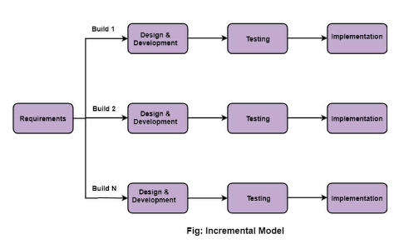

## 3.8 Technology for Development

A programming tool is a computer program that software developers use to create, debug, maintain or otherwise support other program applications. The programming tools to be used are;

1. Scripting languages: PHP

2. PhpMyAdmin

3. MySQL

# **CHAPTER 4:** **DATA ANALYSIS, INTERPRETATION OF FINDINGS AND SYSTEMS DESIGN**

### DATA ANALYSIS, INTERPRETATION OF FINDINGS AND SYSTEMS DESIGN

## 4.0: Introduction

The results of the descriptive statistical analysis of the data and their interpretations are presented. The data collected from the respondents who were frequent customers, workers and managers of Jim-X online booking salon and spa, was summarized and tabulated, researcher used statistical goggle forms: online survey. The descriptive statistics used are the frequencies, percentages and graphs. Descriptive statistics help to develop the basic features of the study and form the basis of virtually every quantitative analysis of the data. The results are presented in terms of the study objectives.

## 4.1: Presentation of Findings

### 4.1.1: Questionnaire Return Rate

71 questionnaires were given out randomly to respondents ranging from customers, workers and managers of different salons in Jim-X. A total of 67 questionnaires were returned for analysis. This represented a 96% percent return rate of the respondents. Overall, the response rate was 96% because 8 respondents did not return their questionnaires.

|  |  |  |  |  |
| --- | --- | --- | --- | --- |
|  | Frequency | Percentage | Valid percentage | Cumulative percentage |
| Valid Response | 42 | 80.0 | 80.0 | 80.0 |

Table 1: Questionnaire Return Rate

### 4.1.2: Category of Respondents

The study sought to find out the distribution of the respondents to know in which category each of them belonged to. 7.3% were managers, 41.8% were employees of various positions, for example casual, 50.9%frequent customers.

### 4.1.3: Computer usage skills

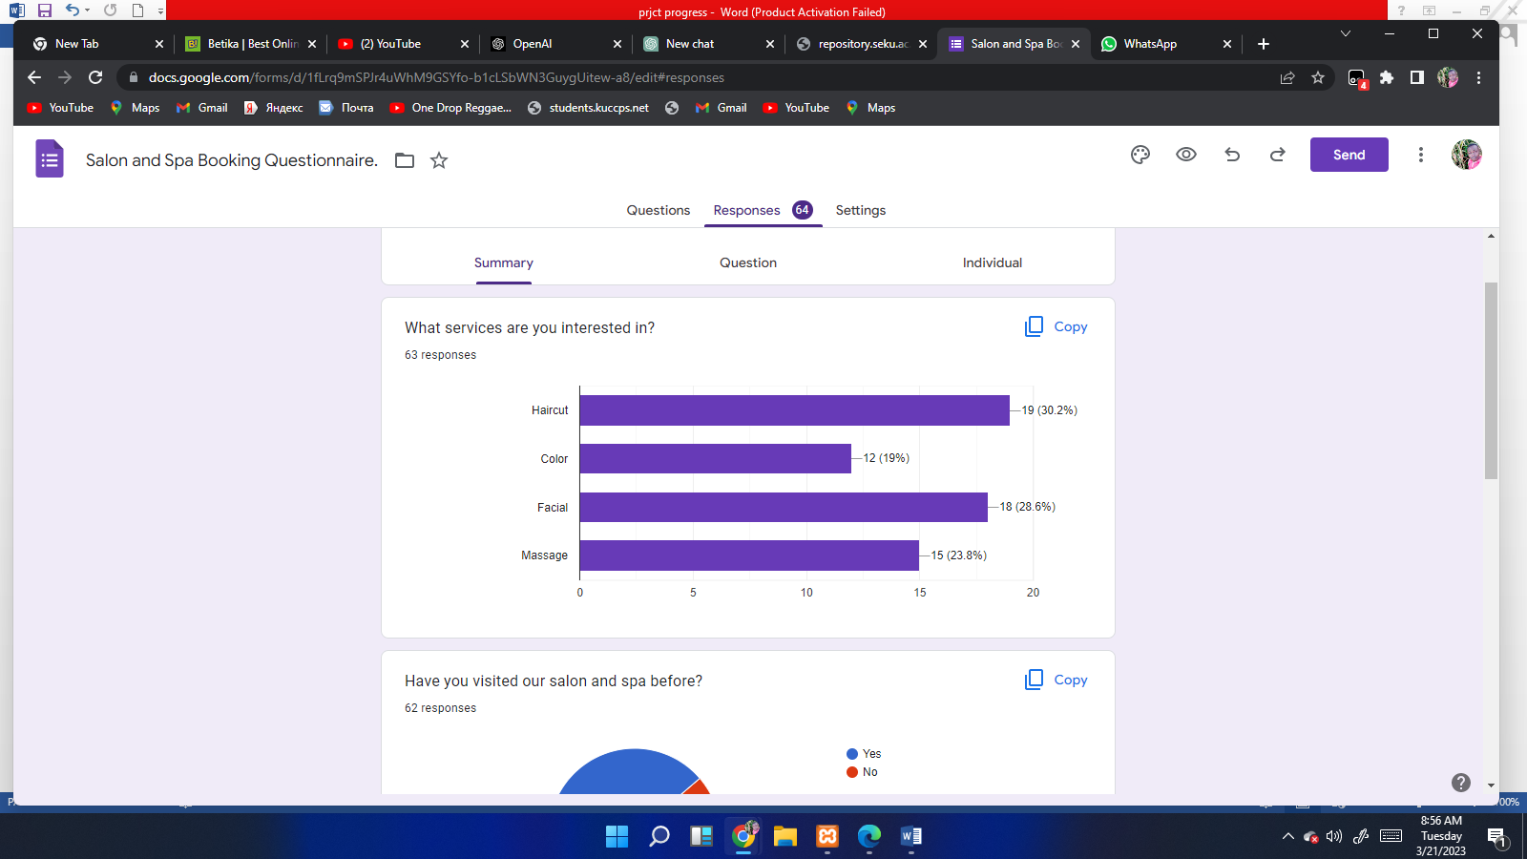

Figure 1. Bar graph of different services

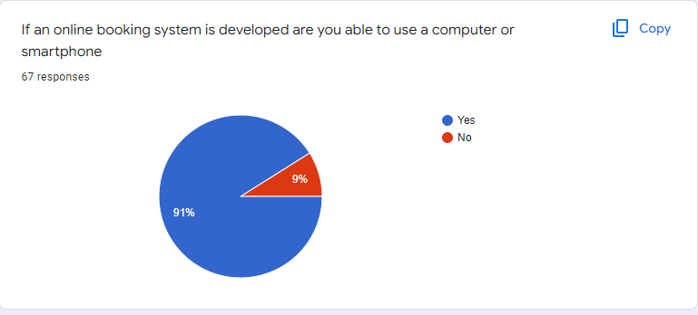

Figure 2. Pie chart on computer literacy

# Screenshot (69)

Figure 3.

# Screenshot (121)

Figure 4: opinion on the proposed system

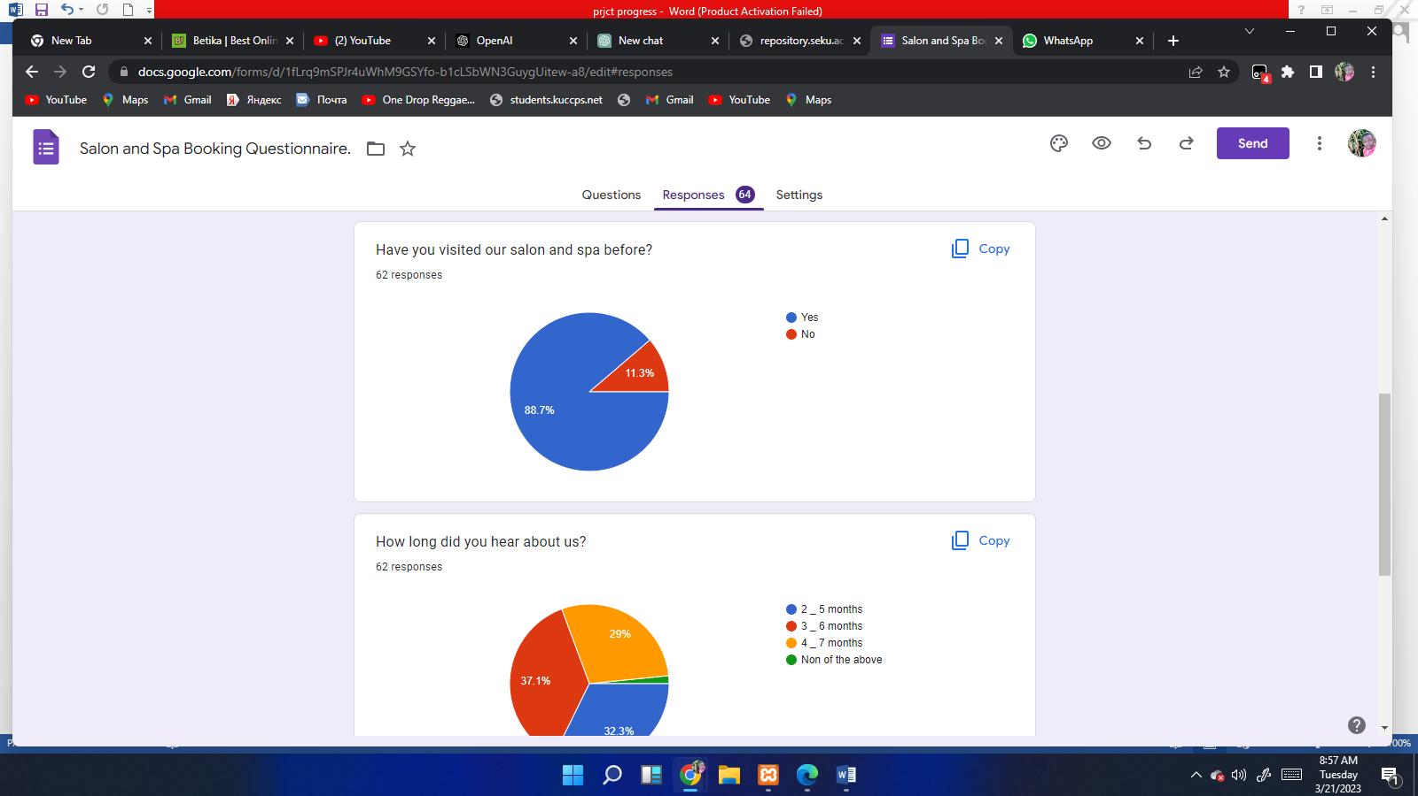

Figure 5: Pie chart on visiting the salon and spa

# 

Figure 6. Pie chat on mode of payment

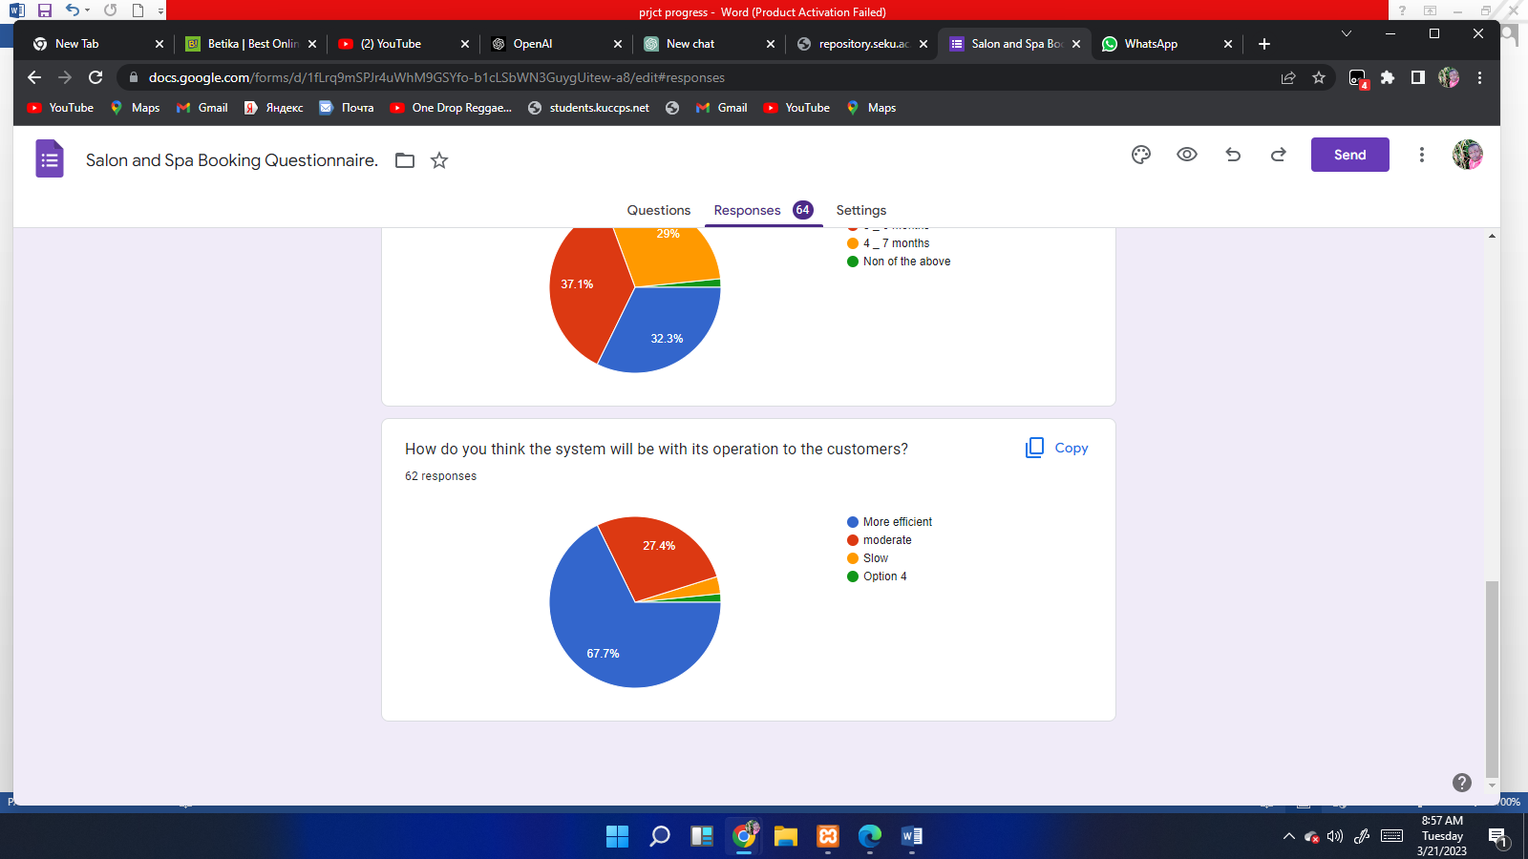

Figure 7. Pie chart on how effective the system is

4.2: Summary of Findings

This study reveals that Jim-X online booking spa and salon is one of the largest online booking salons and spa since it serves more than 50 customers per day, this is because customers book their appointment in prior time.

## 4.3: System Aanalysis

In the system analysis we chose to use the Object-Oriented System Analysis. This is due the fact that our system employed the object-oriented approach and due to the use of a php programming, the use of the object-oriented System Analysis was and appeared to be more appropriate than the other approaches that exist towards the same. (Lerdorf R.& McIntyre, P, 2006) The diagrams that illustrate the systems flow of information are shown below:

### 4.3.1: Description of the existing system

The existing system is outdated in that customers do not know about the services offered in most salons until they visit there or make phone calls, Customers also do not have any idea of when the salon is open or closed.

The old system is time consuming and tiresome as most calculations and receipts are done manually.

### 4.3.2: Description of the proposed System

The new proposed system will offer online booking, which is secure. There will be a section for local customers to book their appointments through the admin. Services will be booked online and phone calls will be made by the admin to clarify customers' bookings. Cash operation I.e. calculation and total sales will be automated, the proposed system will improve customer relation.

### 4.3.3: Requirements Specifications

#### **4.3.3.1: Functional and Non-Functional Requirements**

1. The System aims at providing an efficient interface that will assist the user in management of inventory, it shall also provide the user varied options for managing the inventory through various functions at hand. The autosuggest feature will save time when filling forms.
2. The System also notifies the manager when inventory is running low and give them time to order new stock.
3. The simple interface of the System has functions like adding a customer, putting together sales reports and removing or updating a product. It also extends to functions such as adding a supplier for an ingredient, removing the supplier, checking product levels, processing orders, altering processed orders etc.
4. Usability- The system must be easy to use, accessible and easy to navigate by both managers and chefs such that they do not need to read an extensive manual.
5. Reliability- the System must give accurate inventory status to the user continuously. Any inaccuracies are taken care by the regular confirming of the actual levels with the levels displayed in the system. The System must successfully add any vendors or products given by the user and provide estimations and inventory status. The system must provide a password enabled login to the user to avoid any foreign entity changing the data in the system. The system should not update the data in any database for any failed processes.
6. Performance- The system must not lag, because the workers using it don’t have down-time to wait for it to complete an action. The system must complete updating the databases, vendor and sales successfully every time the user requests such a process. All the functions of the system must be available to the user every time the system is turned on. The calculations performed by the system must comply according to the norms set by the user and should not vary unless explicitly changed by the user.
7. Supportability**-** The software is designed such that it works even on systems having the minimum configuration. The system is adaptable even if additional plugins or modules are added at a later point. The data can be exported to the manager so as to make the system more portable.
8. Packaging- The system must be able to run on the Windows operating systems beginning with Windows XP, and must be able to run on current releases such as Windows 10.
9. Interfacing**-** The system must offer an easy and simple way of viewing the current inventory and sales reports. The system must be able to display the relationships between suppliers, their products and sales made to customers.

## 4.4: System Design

### 4.4.1: Context Diagram

A data flow diagram is a graphical representation of the flow of data through an information system, modelling its process aspects. A DFD is often used as a preliminary step to create an overview of the system, which can later be elaborated. DFDs can also be used for the visualization of data processing.

A DFD shows what kind of information will be input to and output from the system, where the data will come from and go to, and where the data will be stored. It does not show information about the timing of process or information about whether processes will operate in sequence or in parallel.

The figure below shows the flow of information in the Jim-X salon and spa ecommerce website which entails two users of the system, and these are the administrator and customer.

### 4.4.2: Use Case Model

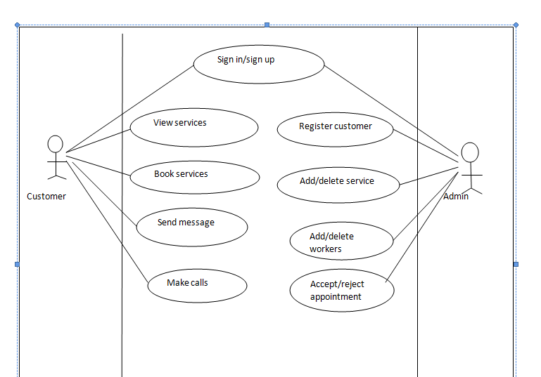

### 4.4.3: Sequence Diagrams

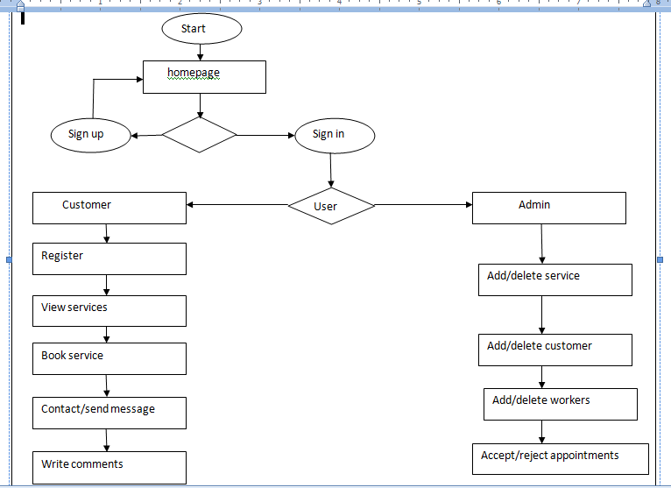

### 4.4.4 Activity Diagram

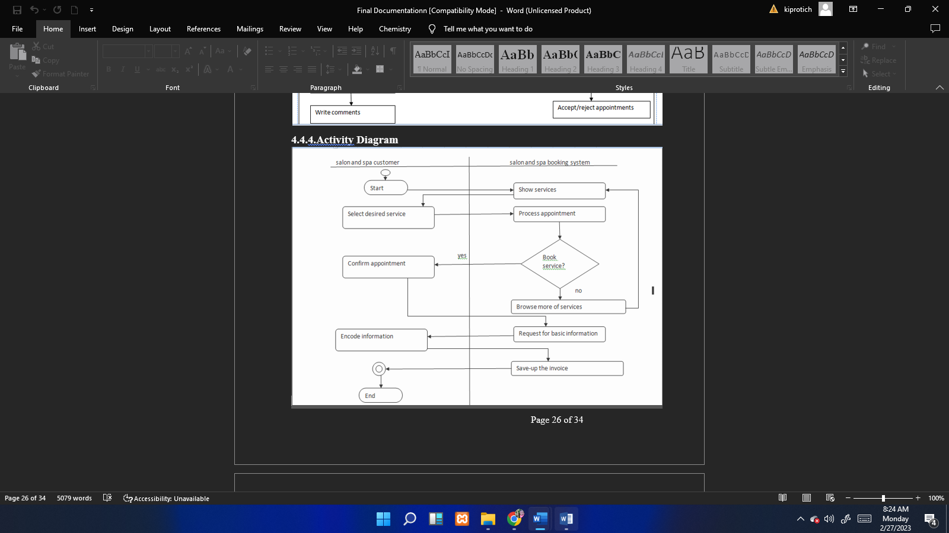

## 4.5: Interface Designs

### 4.5.1: Login page for admin

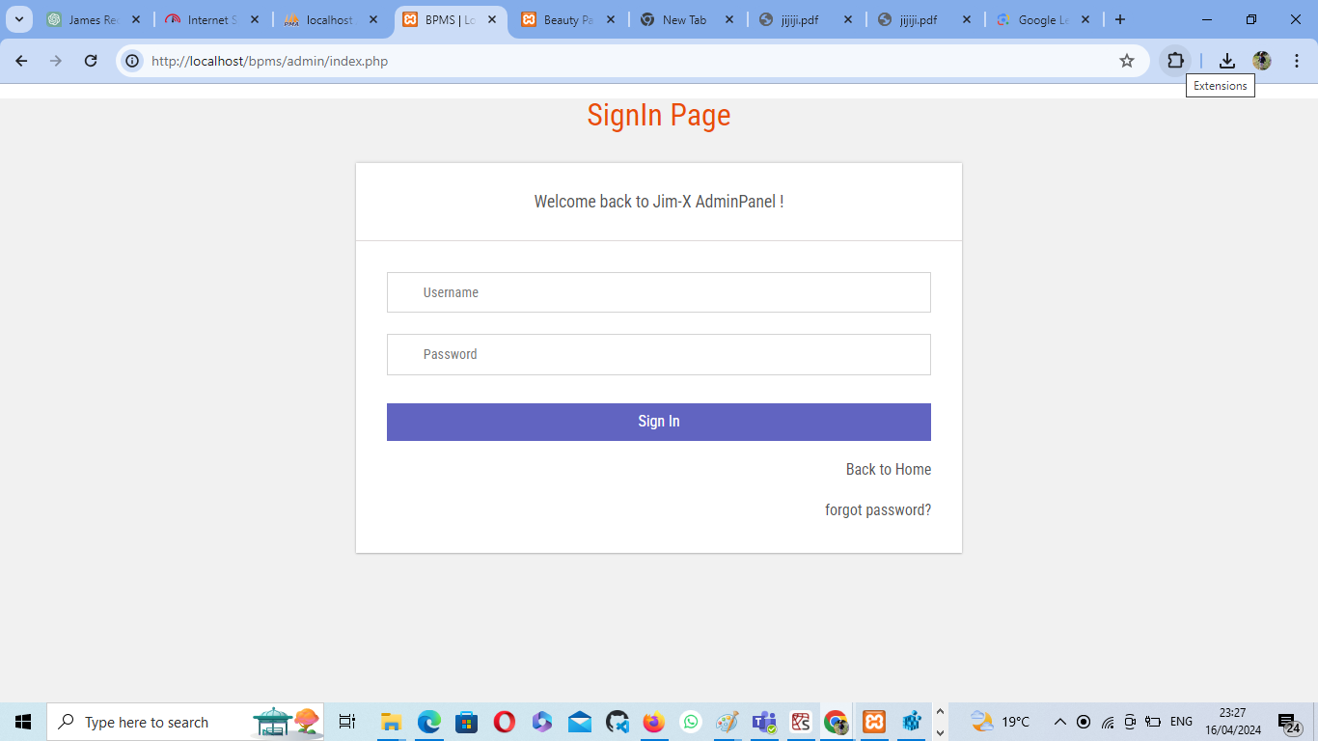

**4.5.1: Admin Server**

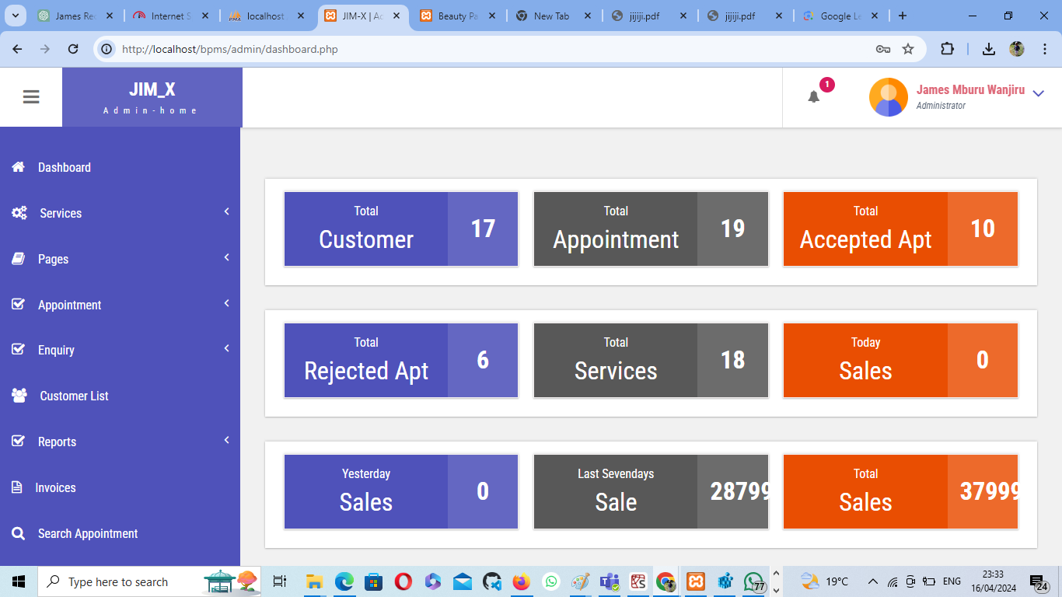

4.5.2: Home Page

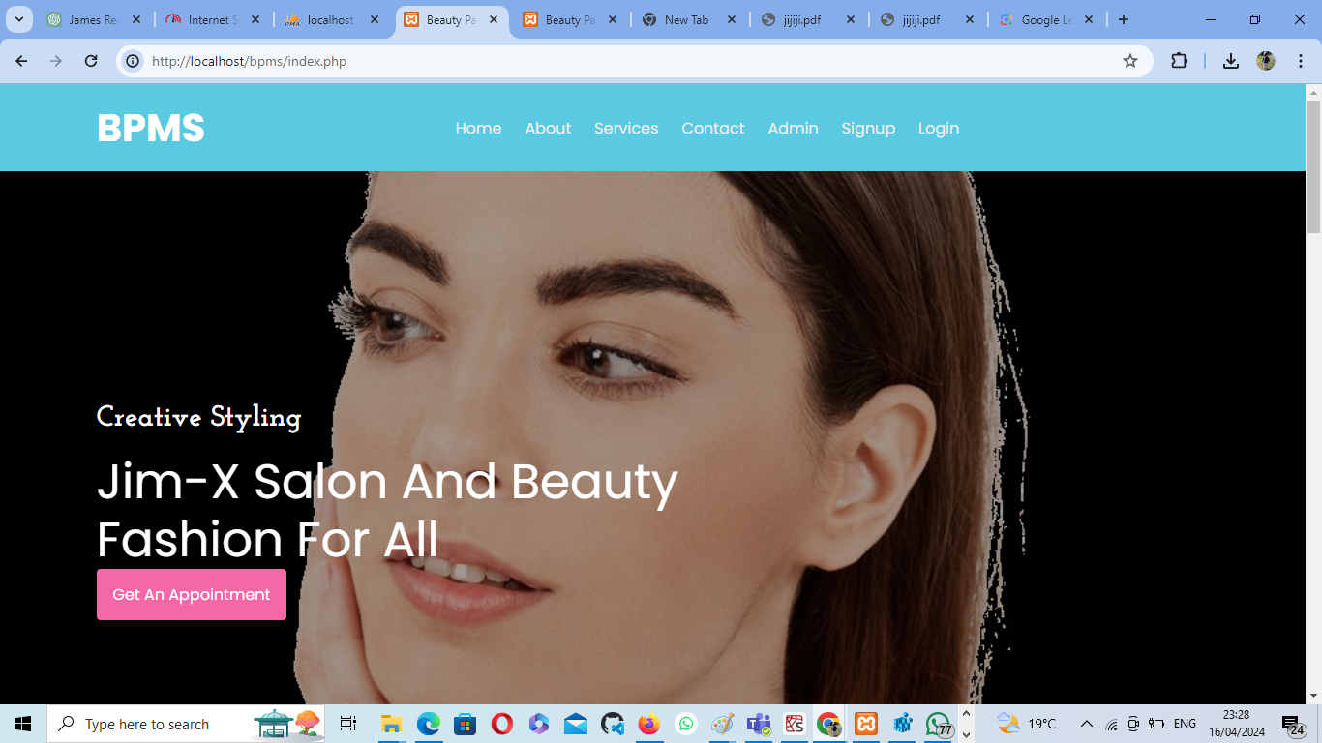

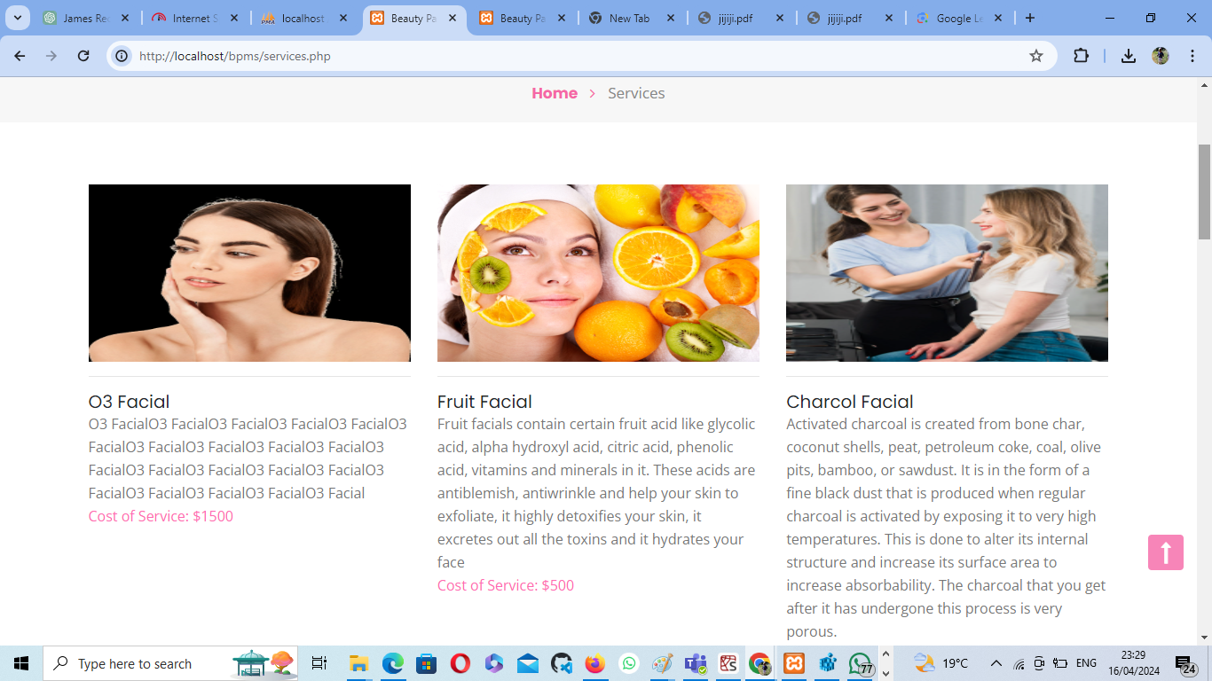

## 4.6: Database Design

### 4.6.1: Customer Table

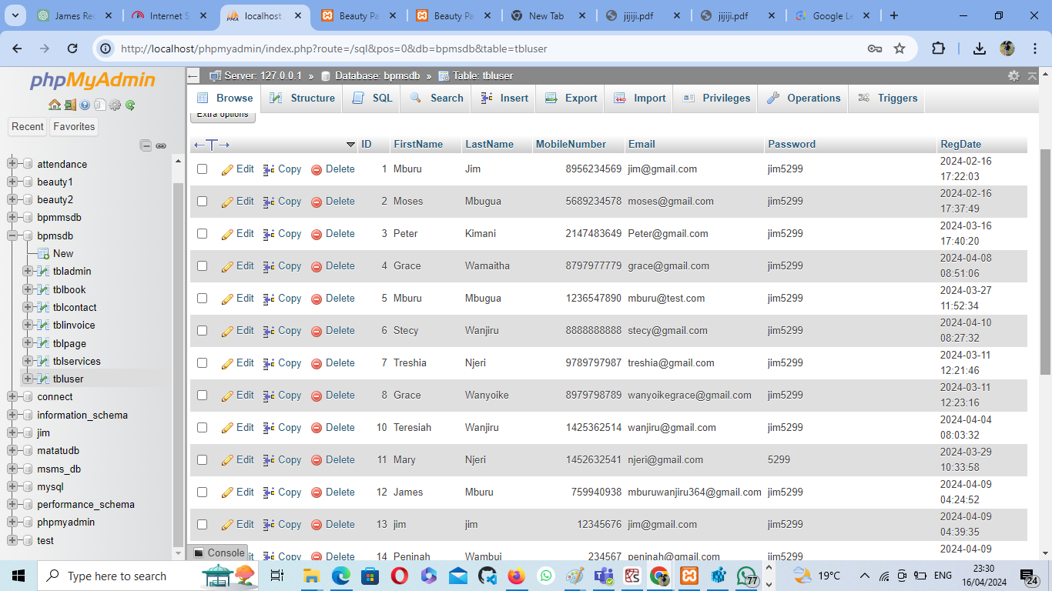

## 4.7: System Implementation and Testing

### 4.7.1: System testing

Last phase is system testing done when development is complete, and the system is ready for deployment. The testing phase comes next to determine if the earlier intended objective has been realized by then. Testing was done based on whether completeness will have been realized or functional testing that determined whether the software is doing what it is expected correctly and in the right way.

### 4.7.2: System Output – Reports

#### **4.7.2.1: Add/manage services**

This feature will allow the admin to add and manage the services in the database. The administrator selects the services from the records to view the details of the services. The System responds by displaying the entire details of that service. System must be able to fetch the correct details from the database and display them to the farmer.

#### **4.7.2.2: View appointments**

This feature is used by the system admin. This feature allows the system admin to view all the services booked by the customers. Once the services have been stored in the system’s database, the customer can be able to view the details of that product.

#### **4.7.2.3: Accept/reject appointment**

This feature will allow the admin to accept or reject appointments and view the messages and invoices by the customers.

## 

# **CHAPTER 5: SUMMARY OF FINDINGS, CONCLUSIONS AND RECOMMENDATIONS**

## 5.1: Introduction

This chapter summarizes the findings of the study and makes conclusions upon which recommendations are drawn. Suggestion for further study is also captured as a way of filling the gaps identified in the study. The chapter also summarizes the findings of the current method of the system and whether to adopt the online salon booking system.

## 5.2: Summary of findings

This system will help in elimination of chances of human error and there will be no more forgotten bookings and it improves customer experience. Since it is online, your booking is always available, and customers can book at any time and from anywhere.

## 5.3: Conclusions

In conclusion I would like to say that taking this project all through has been a wonderful experience for me. Without the practical knowledge that I acquired throughout the course, this project would not have materialized. This is a very important part of my course and has helped me familiarize myself with the market expectations of the course at large. The project also helped me realize that having a framework from which I was working from, simplified most details to make the project a success.

## 5.4: Recommendations

This system is an online booking salon and spa website so every user of our system should have knowledge how to use computers and mobile application.

To use the website, every user should:

* The user should have at least a computer facility or a smart phone to use the website effectively.
* Budget should be allocated to take specific measure, such as:
  + - * To maintain the system in a timely and speedy manner.

## 5.5: Suggestion for further study.

Implementation of a chat platform where admin will be able to chat with the client

Google maps implementation for logistics

# **References**

Sutanto's, P.H., 2020. Ecommerce Design Based Multi-VendorKatalog Indonesia: Ecommerce Design Based Multi-Vendor Case Study PT. Mutiara Katalog Indonesia. *Journal Mantik*, *3*(4), pp.1-10.

Li, L. and He, H., 2020. How to Implement the Commodity Publishing System in Ecommerce Platform. In *IOP Conference Series: Materials Science and Engineering* (Vol. 719, No. 1, p. 012002). IOP Publishing.

Saetang, S., 2017, August. The E-Commerce strategies respond to the UX design. In *2017 10th International Conference on Ubi-media Computing and Workshops (Ubi-Media)* (pp. 1-6). IEEE.

Nkwo, M. and Orji, R., 2018. Persuasion in eCommerce. In *Proceedings of 2nd African Computer Human Interaction Conference (AfriCHI’18), Windhoek, Namibia* (Vol. 4).

# **APPENDICES**

## APPENDIX A: PROJECT BUDGET

|  |  |
| --- | --- |
| **ITEM** | **ESTIMATED COST (KSHS)** |
| Computer/laptop | **40,000** |
| Android mobile phone | **17,500** |
| Data analyst | **3,500** |
| Travelling | **1,800** |
| binding | **200** |
| printing | **500** |
| Internet connection | **2,500** |
| **Total** | **66,000** |

# 

# **APPENDIX B: IMPLEMENTATION SCHEDULE**

|  |  |  |  |  |  |  |  |
| --- | --- | --- | --- | --- | --- | --- | --- |
|  | **Date** |  |  |  |  |  |  |
| **Activity** | **Sept** | **Oct** | **Nov** | **Dec** | **Jan** | **Feb** | **Mar** |
| Project proposal |  |  |  |  |  |  |  |
| Requirement analysis |  |  |  |  |  |  |  |
| planning |  |  |  |  |  |  |  |
| Design |  |  |  |  |  |  |  |
| Coding |  |  |  |  |  |  |  |
| Testing and debugging |  |  |  |  |  |  |  |
| Documentation and presentation |  |  |  |  |  |  |  |

# **APPENDIX C: HARDWARE REQUIREMENT**

|  |  |
| --- | --- |
| **Hardware** | **Description** |
| Operating system windows | Windows XP, 10 |
| Computer Processor | Intel core I 5 2GH |
| Computer RAM | 2GB |
| Hard disk | 500GB |
| Monitor | 15 inches CRT or LCD |
| Keyboard | Normal or multimedia |
| Mouse | Compatible |

# **APPENDIX D: SOFTWARE REQUIREMENT**

|  |  |
| --- | --- |
| **Software** | **Description** |
| XAMPP | 1&2 |
| APACHE server | 5.4.19 |
| Adobe Dreamweaver | CS 6.0 |
| MYSQL server | 5.4 |
| Browser | Google chrome |

# **APPENDIX E: SAMPLE CODE**

